# Assignment 4: Slowly Changing Dimension

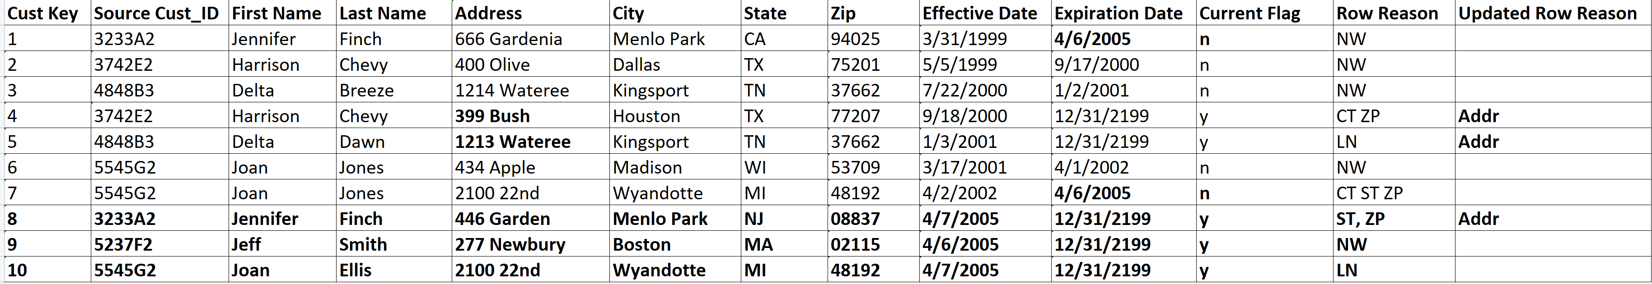

**Explanation of the Slowly Changing Dimension above table:**

1. For the 1st person – **Jennifer Finch** – There are changes in the Address, State and Zips. Address changes are basically type 1 change whereas State and Zip is type 2 change as per the criteria stated in the above context. Both Type 1 and Type 2 changes exist in the record and therefore Type 2 will take precedence over Type 1 and therefore a new row is inserted where Cust Key is 8 with the changes in effect such as the address as 446 Garden, State as NJ and Zip as 08837 with effective date as 4/7/2005 and expiration date as 12/31/2199 and the previous record will have current flag as n and expiration date as 4/6/2005
2. For the 2nd person – **Jeff Smith** – This is a new record which never existed before and therefore we can insert the record to the dimension table with all the information where Cust Key is 9 with the effective date as 4/6/2005 and expiration date as 12/31/2199
3. For the 3rd Person – **Harrison Chevy** – There is an update in the address only. Address change is a type 1 change and therefore we should directly update the existing active record where Cust Key is 4. The change will be from 392 Bush to 399 Bush
4. For the 4th Person – **Delta Dawn** – There is a change in the Address only. Address change is a type 1 change and therefore we should directly update the existing active record where Cust Key is 5. The change will be from 1214 Wateree to 1213 Wateree
5. For the 5th Person – **Joan Ellis** – There is a change in the last name only. Last name change is a type 2 change and therefore we should insert a new record with last name changed to Ellis and the effective date will be 4/7/2005 and expiration date will be 12/31/2199 and for the previous record will have current flag as n with expiration date as 4/6/2005